~Solve by Factoring Notes~

**MCC9-12.A.REI.4: I can solve a quadratic equation with one variable.**

1. **Quadratic Equation** – any _____________where _____is the _____________ exponent.
2. **Standard form of a quadratic equation:**

* Solutions and Roots:
  + The **_______________________** is used to solve an equation when one side is zero and the other side is a product of polynomial factors
  + For example: m · n = 0, then m = 0 or n = 0. The solutions of such an equation are also called **_____________.**

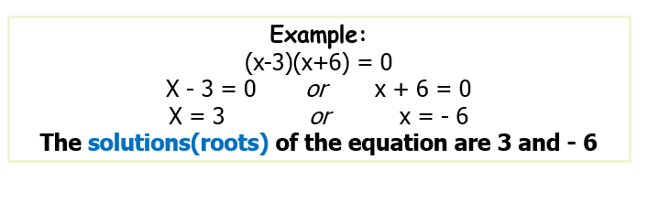

**Examples:**

|  |  |
| --- | --- |
| 1. (k + 1)(k – 5) = 0 | 1. (a + 1)(a + 2) = 0 |
| 1. (4k + 5)(k + 1) = 0 | 1. (2m + 3)(4m + 3) = 0 |
| **Factor and then Solve:** | |
|  |  |

Solve:

**6x2 + 12x = 0**

|  |  |
| --- | --- |
| 1. b2 + 14b = 0 | 1. 24k2 + 24k = 0 |

What if we have a problem that looks like this…What should we do?

Or like this…

1. 9p2 -36 = 0

Review:

|  |  |
| --- | --- |
|  |  |
|  |  |